**Class 9 - Content: Number data in graphs and charts**

I – Objective: Understanding number data in graphs and charts

Warm up: song: Gavin James – Always - <https://www.youtube.com/watch?v=hSmdueR0SwM>

Problem 1: At work or at university you sometimes need to explain number data using charts or graphs. So, to practice this sort of situation, prepare an oral presentation using number data. You can choose from a chart or a graph and you can also choose the data from work, school, or news. (3,0 pontos)

To help you to solve the problem, you can do the following activities or choose your own way:

1-Reading and vocabulary: You are going to read an extract about charts and graphs to understand how they function.



(from <https://www.shutterstock.com/pt/image-photo/businessmen-meetings-using-white-board-229607368>)

**How to describe a graph**

Once you create a graph or chart for your [presentation](https://preply.com/en/blog/how-to-start-a-presentation-and-grab-your-audiences-attention/), it is time to know how to describe it.

**Introduce the graph**

Your first step should be to present the graph to your audience, like: its title, the topic, data source. Here are some examples of how to do this:

* This graph shows the relationship between ------ and --------.
* This chart uses data from the ----------.
* The data in this graph is from ---------.

**Vocabulary**

To describe the movement of the line, you should use appropriate [verbs](https://preply.com/en/learn/english/grammar/verbs), [adjectives](https://preply.com/en/learn/english/grammar/adjectives), and [adverbs](https://preply.com/en/learn/english/grammar/adverbs) depending on the kind of action you need to show.

**Verbs:** rise, increase, grow, go up to, climb, boom, peak, fall, decline, decrease, drop, dip, go down, reduce, level up, remain stable, no change, remain steady, stay constant, stay, maintain the same level, crash, collapse, plunge, plummet.

**Adjectives:** sharp, rapid, huge, dramatic, substantial, considerable, significant, slight, small, minimal, massive.

**Adverbs:** dramatically, rapidly, hugely, massive, sharply, steeply, considerably, substantially, significantly, slightly, minimally, markedly, quickly, swiftly, suddenly, steadily, gradually, slowly.

**Line graph:**

Here’s a sample of a line chart with the exam question for the IELTS:

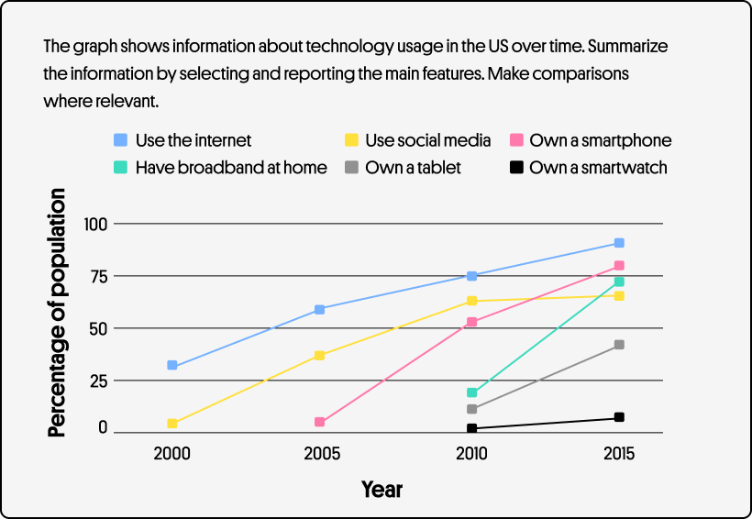

**Bar graph:**

To describe the graph, follow the trend from left to right. Then explain if it goes down, up, or stays the same. The words used to describe bar charts are similar to the ones used for the line charts. Let’s have a look at the exam question for the IELTS writing test:

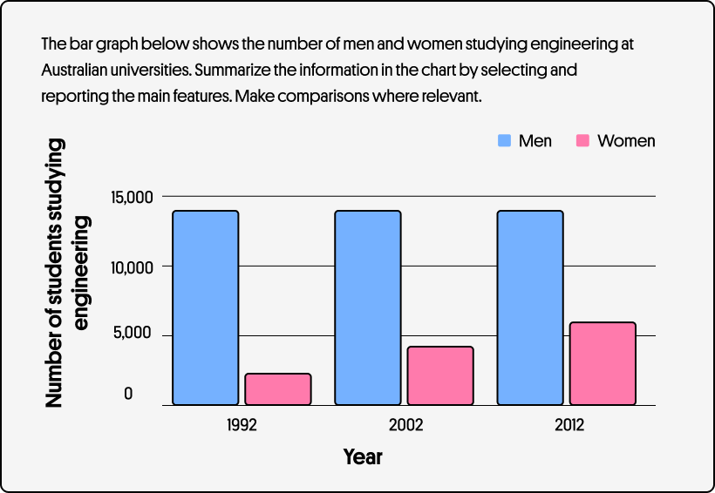

**Pie chart:**

Here we have an example of a pie chart that represents how internet users aged 16+ prefer to browse the web:

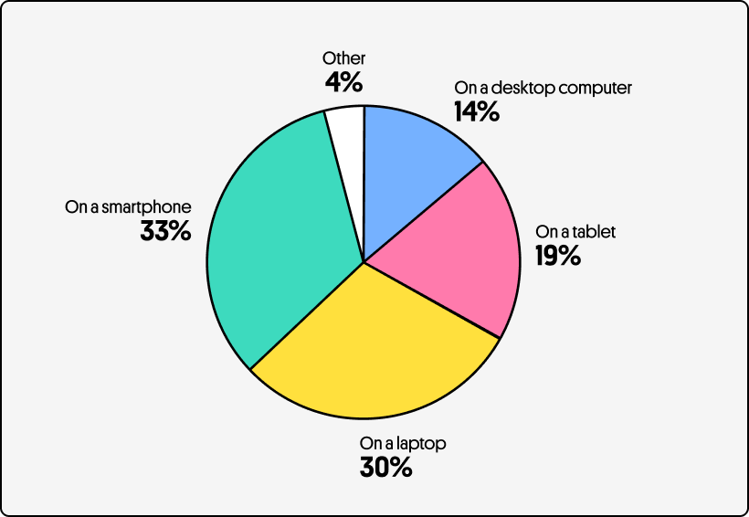

(adapted from <https://preply.com/en/blog/how-to-describe-graphs-in-english/>)

**Class 10 - Content: Number data in graphs and charts**

I – Objective: Understanding number data in graphs and charts

Warm up: song: Imagine Dragons – Birds - <https://www.youtube.com/watch?v=JxHt43-1inE>

2 – video: watch the following video to improve vocabulary related to describing graphs and charts; take notices if necessary.

<https://www.youtube.com/watch?v=tApPdt_Y8jE>



3- Exercises: Now you are going to practice using graphs by doing the following exercise:

3.1- These graphs show busy periods in the year for three types of business: delivering flowers, selling houses and trade fair industry. (from Business Result Elementary, by Grant, Hughes & Turner, page 72)

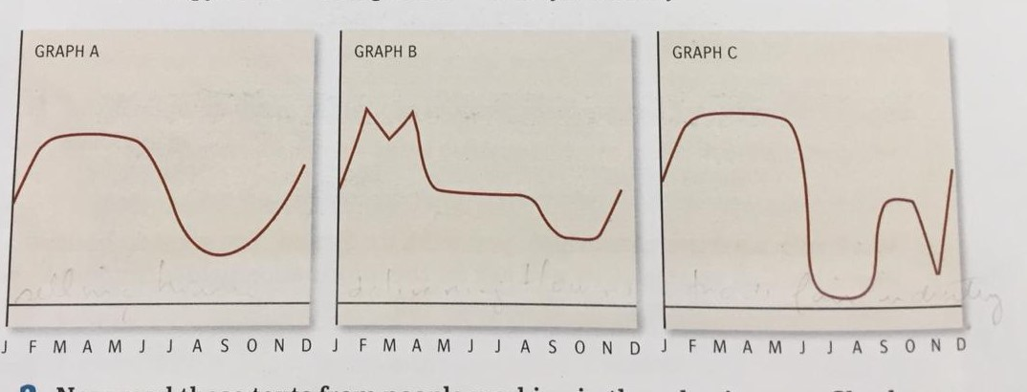

Read these texts from people working in these businesses, and then match the businesses to the graphs.

**1-Katrina Bieber works in the German Trade Fair Industry:**

‘60% of all major international trade fair now take place in my country, and January to mid-May is the really busy period. So I can usually take my annual leave in June or July and then some more time off in the autumn before I start planning again for next year’.

**2-Prescott Bowden runs a real estate firm in Atlanta, Georgia:**

‘People always think spring is a good time for selling houses, but you can’t predict the market these days. For example, Christmas is the time when everyone has busy schedules, so you expect real estate to have a quiet period. But last year, December was one of our best months’.

**3-Jayne Henry is a sale manager for a flower company:**

‘We promise to deliver flowers the same day so we have very tight deadlines. We also need to be sure we have the right amount of staff. For certain public holiday or Valentine’s Day and Mother’s Day we need about 80 people and five team leaders. During quiet weeks we only have about 10 full-time staff in the centre’.

**Class 11 - Content: Number data in graphs and charts**

I – Objective: Understanding number data in graphs and charts

3 – Speaking: prepare the oral presentation with number data as suggested in problem 1.



(from <https://www.freepik.com/free-photos-vectors/students-studying>)

**Class 12 - Content: Number data in graphs and charts**

I – Objective: Understanding number data in graphs and charts.

4 – Oral presentation: Oral presentation of the activity suggested in problem 1. (3,0 pontos)



(from <https://www.freepik.com/free-photos-vectors/student-presentation>)